**The Effect of Shortened Work Week on Economic Outcomes**

Tucker Tracy and Karsen Brantley

February 2023

**ABSTRACT**

The implementation of shorter work weeks in Europe have opened the door for research on the economic effects of these policies. Iceland recently underwent trials which introduced a four-day workweek. Towards the end of the trials, in 2021, around 86% of the country’s labor force had the option to incorporate a shorter work week. Our paper looks to use these trials to evaluate the effects of a shortened work week on three different economic outcomes: industry (further broken down into six subgroups), labor productivity, and emissions. Three difference-in-difference regression models are run to compare the outcomes between a control group and a treatment group. The control group consists of Norway and the Netherlands. The treatment group is Iceland. Results from our labor productivity model indicated that labor productivity increased by approximately 1.9% after the Iceland trials, and results from every subgroup of the industry model indicated statistically significant differences in industry GDP before and after the Iceland trials. In our emissions model, the variables that demonstrated a significant effect on emission levels were the year variable, material consumption, and the dummy variable for our treatment group. The data used in the regressions comes from the Organization for Economic Co-operation and Development.

**Introduction**

Recent European policy changes have caused many countries to adopt shorter work weeks with the goal to improve worker productivity and quality of life. These policy changes have been followed by research that aims to answer questions about the economic impact of reduced working hours. One of the significant areas studied is health effects, which may include exercise, social interactions, or adverse health effects. Ahn (2015) finds that in South Korea, there is an association between an increase in one hour of work per week had a negative effect on the amount of exercise a person performs, as well as a positive effect on the amount of smoking and drinking they take part in. Another study on quality-of-life outcomes presented by Lepinteur (2016) found that a reduced work week results in an increase in both job and leisure satisfaction in Portugal, as well as job satisfaction in France.

           A large area of the literature also looks at workload and worker productivity. There is some contradiction in this area of focus. Many papers have significant findings, such as an article by Sheikh Ali (2013), which found that a significant workload reduced workers’ productivity. Okazaki et. al. (2018), among others, found that working hours do not significantly affect productivity. It is important to remember that not all industries operate under the same logic. The service industries’ productivity is not directly correlated to the hours they work. A service worker’s productivity does not directly decrease because of the number of hours that employee has worked. Contrarily, in the manufacturing industry, an employee’s hours worked are correlated with that employee’s productivity. That is an example of how industries are uniquely affected by shorter working week policies.

Iceland recently underwent trials to introduce a 4-day work week. Two trials were implemented which reduced the work week of over 2,500 individuals from 40 hours a week to 35-36 hours a week. The trials aimed to increase worker productivity and quality of life around the country. Haraldsson and Kellam (2021) reported that productivity either increased or stayed the same throughout the trials, while worker well-being improved across multiple facets, including perceived stress, burnout, health, and work-life balance. Following the trials, policies reducing working hours were implemented across Iceland, and around 86% of the country either moved to shorter work weeks or has the option to move to a shorter work week.

           While there is sufficient literature on the relationship between working hours and both productivity and health, this research looks to add to the existing literature by reinforcing the data on labor productivity, introducing possible effects on emissions, and providing more detail by breaking GDP down into industry categories.

           Our methods section will introduce our model, the dependent variables, and the control variables. The data section will overview the data sources and provide descriptive statistics for the data. Finally, our results section will present the empirical data and corresponding graphs.

**Methods**

 The effect of shortened working hours on different economic aspects is evaluated using three models that compare the change in these aspects between the control and treatment groups.

Model 1

Industry = β0 + β1Adult_Educ + β2Hours_Worked + β3Working_age_population + β4Treatment_Groups + β5Post_Treatment_Group + β6Treatment_Groups*Post_Treatment_Group + ε

Model 2

Labor Productivity = β0 + β1Adult_Educ + β2Hours_Worked + β3Working_age_population + β4Treatment_Groups + β5Post_Treatment_Group + β6Treatment_Groups*Post_Treatment_Group + ε

Model 3

Emissions = β0 + β1GDP_per_capita + β2Freight_Transport + β3Material_Consumption + β4Treatment_Groups + β5Post_Treatment_Group + β6Treatment_Groups*Post_Treatment_Group + ε

The control variables for all industry and labor productivity outcomes include Adult Education Level, Hours Worked, and Working Age Population. Adult Education level is a variable that indicates the percent of a country’s population between the ages of 25 and 64 that have completed tertiary education. Hours Worked indicates the average annual hours worked per person in a country. Working Age Population indicates the percent of the total population that falls into the working age category, defined as ages 15 to 64. The industry regression is run for six different industry categories to provide a more detailed breakdown. These categories include agriculture, energy, manufacturing, construction, financial and insurance, and real estate. There is potential omitted bias in our models. A potential explanation of the dependent variables that is missing is the talent of the work force. A highly talented work force is likely to increase both overall industry performance and the overall productivity of the labor force.

           The control variables included in the emissions model are GDP per capita, freight transport, and material consumption. GDP per capita is the nominal GDP (GDP at current prices) in US dollars per capita. Freight Transport indicates the total movement of goods through inland transport in a million tonne-kilometers. Material Consumption indicates the number of materials used in the economy in tonnes/capita.

Treatment_Groups is a dummy variable for observations in Iceland, the country affected by the reduced work week. Post_Treatment_Group is a dummy for observations during or after 2017, when the policy was implemented. The coefficient of the variable Treatment_Groups*Post_Treatment_Group explains the causal effect of reduced working hours on the treated group Iceland. We run a difference-in-difference regression on each model to determine the causal effect of the policy in Iceland on each of our dependent variables.

**Results**

**Figure A: Difference-in-Difference Model on Industry (Subgroup Agriculture)**

**Table A: Difference-in-Difference Model on Industry (Subgroup Agriculture)**

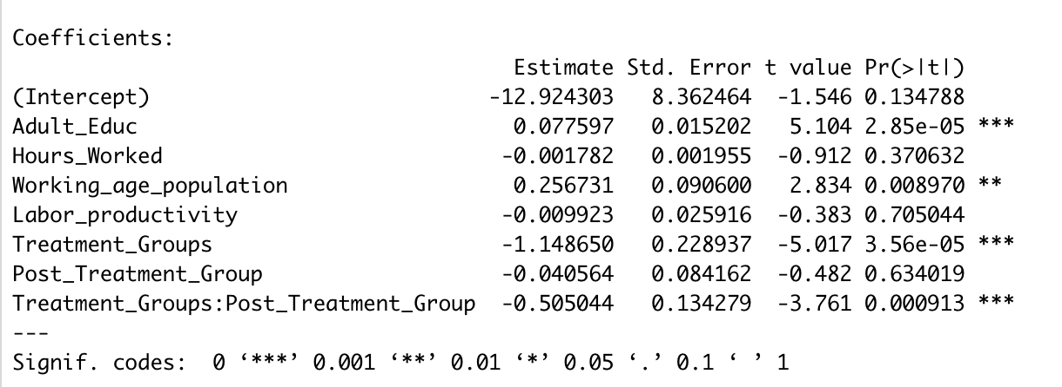

In Table A, there are four statically significant variables. For every one unit increase in adult education level, GDP for Agriculture increases by ~0.78% and is significant to the 0.001 confidence level. For every one percent increase in the working age population, GDP for Agriculture increases by ~2.57% and is significant to the 0.01 confidence level. Lastly, the interaction term is statically significant to the 0.001 confidence level, revealing that there is a unique effect from reduced working hours on Agriculture GDP. The coefficient indicates Agriculture GDP decreases by approximately 5.05% if the country is in the treatment group and is statistically significant to the 0.001 confidence level.

**Figure B: Difference-in-Difference Model on Industry (Subgroup Energy)**

**Table B: Difference-in-Difference Model on Industry (Subgroup Energy)**

In Table B, there are five statically significant variables. For every one unit increase in adult education level, GDP for Energy increases by ~1.16% and is significant to the 0.001 confidence level. For every one percent increase in the working age population, GDP for Energy increases by ~4.39% and is significant to the 0.01 confidence level. The dummy variable of Treatment Group is significant to the 0.001 confidence level, the negative coefficient indicates Iceland has lower Energy GDP as compared to the reference group. Lastly, the interaction term between Treatment Groups and Post Treatment Group is statically significant to the 0.05 confidence level, revealing that there is a unique effect of reduced working hours on the treated group, or in this case Iceland. The coefficient explains if the country is treated (Treatment Group = 1) and has data post treatment (Post Treatment Group = 1) then there is an approximate decrease of ~5.29% in Energy GDP.

**Figure C: Difference-in-Difference Model on Industry (Subgroup Manufacturing)**

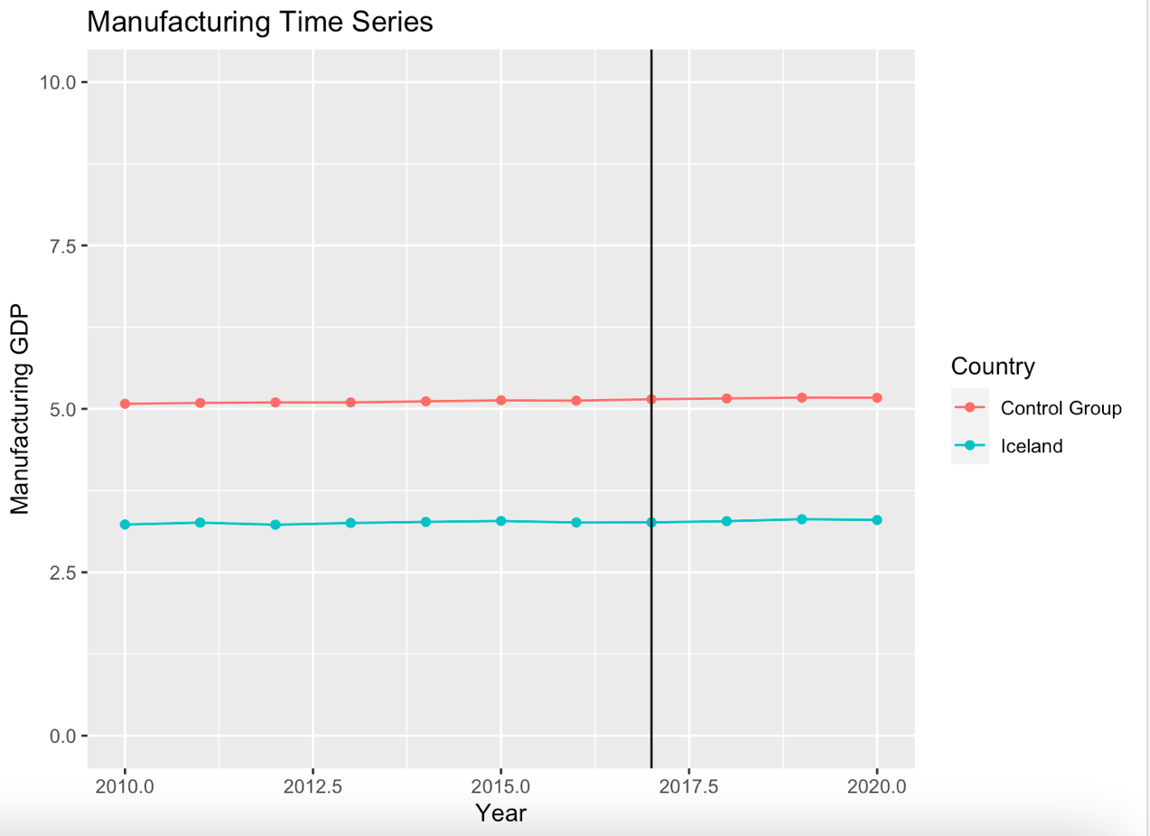

**Table C: Difference-in-Difference Model on Industry (Subgroup Manufacturing)**

In Table C, there are four statically significant variables. For every one unit increase in adult education level, GDP for Manufacturing increases by ~0.59% and is significant to the 0.001 confidence level. For every one percent increase in the working age population, GDP for Manufacturing increases by ~1.88% and is significant to the 0.01 confidence level. Treatment Groups is statistically significant to the 0.001 significance level. Indicting there is a discrepancy in Manufacturing GDP between the treatment group and the control group. The negative coefficient for Treatment Groups explains that the GDP for Manufacturing is lower in the treatment group, Iceland, compared to the control group. The interaction term between Treatment Groups and Post Treatment Group is statically significant to the 0.01 significance level, revealing that there is a significant causal effect of reduced working hours on the treated group Iceland and Manufacturing GDP. The negative coefficient explains the amount of the effect which is an approximate decrease of 2.69% in Manufacturing GDP.

**Figure D: Difference-in-Difference Model on Industry (Subgroup Construction)**

**Table D: Difference-in-Difference Model on Industry (Subgroup Construction)**

In Table D, there are four statically significant variables. For every one unit increase in adult education level, GDP for Construction increases by ~ 0.106% and that is significant to the 0.001 confidence level. For every one unit increase in the working age population, GDP for Construction increases by ~ 0.345% and that is significant to the 0.001 confidence level. The dummy variable of Treatment Groups is statically significant to the 0.001 confidence level, Treatment Groups explains that the if treatment group is equal to 1, in other words Iceland, has a lower Construction GDP by approximately 1.752%. Lastly, the interaction term between Treatment Groups and Post Treatment Group is statically significant to the 0.1 confidence level, revealing that there is a causal effect of reduced working hours on the treated group Iceland and construction GDP.

**Figure E: Difference-in-Difference Model on Industry (Subgroup Financial & Insurance)**

**Table E: Difference-in-Difference Model on Industry (Subgroup Financial & Insurance)**

In Table E, there are five statically significant variables. For every one unit increase in adult education level, GDP for Financial & Insurance increases by ~ 0.04% and is significant to the 0.001 confidence level. For every one unit increase in hours worked, GDP for Financial & Insurance increases by ~ 0.002% and is significant to the 0.1 confidence level. For every one percent in the working age population, GDP for Financial & Insurance increases by ~ 0.140% and is significant to the 0.05 significance level. Treatment Groups is statistically significant to the 0.001 significance level. The negative coefficient for Treatments Groups explains that the GDP for Financial & Insurance is lower in the Treatment Group compared to the Control Group. Lastly, the interaction term between Treatment Groups and Post Treatment Group is statically significant to the 0.05 significance level, revealing that there is a causal effect of reduced working hours on the treated group Iceland and GDP for Financial & Insurance. The negative coefficient explains that GDP for Financial & Insurance decreases by ~ 0.230% if treatment group equals one and post treatment group equals one.

**Figure F: Difference-in-Difference Model on Industry (Subgroup Real Estate)**

**Table F: Difference-in-Difference Model on Industry (Subgroup Real Estate)**

In Table F, there are four statically significant variables. For every one unit increase in adult education level, GDP for Real Estate increases by ~ 0.095% and is significant to the 0.001 confidence level. For every one percent increase in the working age population, GDP for Real Estate increases by ~ 0.284% and that is significant to the 0.01 confidence level. The dummy variable Treatment Groups is statically significant to the 0.001 significance level, Treatment Groups explains the treatment groups has approximately 1.515% less Real Estate GDP than the control group. Lastly, the interaction term between Treatment Groups and Post Treatment Group is statically significant to the 0.05 significance level, revealing that there is a causal effect of reduced working hours on the treated group Iceland and Real Estate GDP. The negative coefficient explains that GDP for Real Estate decreases by ~ 0.350% if treatment group equals one and post treatment group equals one.

**Figure G: Difference-in-Difference Model on Labor Productivity**

**Table G: Difference-in-Difference Model on Labor Productivity**

In Table G, there are no statically significant variables. The interaction term being insignificant can be interpreted as the reduced work week does significantly affect the labor productivity of the workforce.

**Figure H: Difference-in-Difference Model on Emissions**

**Table H: Difference-in-Difference Model on Emissions**

In Table H, there are three statically significant variables. For every additional unit in material consumption, emissions decrease by 0.04793 MtCO2. This effect is significant to the 0.1 confidence level. The Year variable is significant at the 0.05 confidence level, showing that every year emissions decreases by 0.1469 MtCO2. Treatment Groups is significant at the 0.05 confidence level. The negative coefficient explains that being in the treatment decreases emissions by 1.907 MtCO2.

**Figure I: Model Summary of Interaction Term**

**Conclusion**

The first model used industry as the dependent variable and was run six times, once for each subgroup of industry included. Adult Education variables were found to be significant in each industry at the 0.001 level, with individual coefficients present in Tables A through F. The interaction terms for each industry were also significant. This indicates a significant effect before and after the end date of the Iceland trials in activities in Agriculture, Energy production, Manufacturing, Construction, Financial and Insurance, and Real Estate. Coefficients for the interaction terms can also be found in Tables A through F. It can be deduced that the adult education level of Iceland plays a significant role in the productivity of each industry.

Our second model looked at Labor Productivity and found no variables to be significant. The result provides supportive evidence that from before to after the implementation of the shorter work week, the labor force’s productivity had no significant change from before the trials to after the trials. This result implies that although labor productivity did not increase, labor productivity did not decrease. If an employer’s fear is that by introducing shorter work week, their employees will become less productive, then according to our results implementing the shorter work week policies would not have any significant effect on a workforce’s productivity. The concern should be focused on what industry the employer is in as opposed to the productivity of the employees.

           The last model looked at Emissions and found three significant variables. For every additional unit in material consumption, emissions decrease by 0.04793 MtCO2. This was significant at the 0.1 confidence level. The Year variable is significant at the 0.05 confidence level, showing that every year emissions are reduced by 0.1469 MtCO2. It can be observed that with a shorter work week, emissions as a result of material consumption did decrease. In addition to material consumption, every year emissions decreases. As a result of omitted variable bias in our Emissions models, this result is probably not attributed to the shorter work week. Potential variables this result can be attributed to are outcomes of the Paris agreement.

There are also shortcomings to our models. Our models omit variables that are explanatory variables for our dependent variables. As previously mentioned, our industry model does not control for talent and additionally the model does not control for the market environment. The labor productivity model also does not account for talent, or the labor laws in each country. The emissions model falls short because it does not have any data on emissions produced by fossil fuels, or car emissions. These omitted variables understate the value of our emissions results. Despite these shortcomings, there is a vast opportunity for future research in the effect of a shorter work week. One potential future research area would be talent acquisition in the countries with shorter work weeks. That is, do countries where the work week is shorter attract more talent. Another potential future research area is to analyze if a shorter work week reduces emissions produced by passenger cars. Lastly, another research area could be to analyze the effect of the shorter work week on the mental and physical health of workers in the labor force.

**Citations**

Ahn, T. (2016) Reduction of Working Time: Does It Lead to a Healthy Lifestyle?. *Health Econ.*, 25: 969– 983. doi: [10.1002/hec.3198](https://doi.org/10.1002/hec.3198).

Ali, S. (2013) Working Conditions and Employees' Productivity in Manufacturing Companies in Sub Saharan African Context: Case of Somalia. *Educational Research International.* 2. 67-78.

Haraldsson, G. and Kellam, J. (2021) Going public: Iceland’s journey to a shorter workweek.

Lepinteur, A. (2016) The Shorter Workweek and Worker Wellbeing: Evidence from Portugal and France. halshs-01376209

OECD (2022), Air and GHG emissions (indicator). doi: 10.1787/93d10cf7-en (Accessed on 24

September 2022)

OECD (2022), Adult education level (indicator). doi: 10.1787/36bce3fe-en (Accessed on 24

September 2022)

OECD (2022), Freight transport (indicator). doi: 10.1787/708eda32-en (Accessed on 24 September 2022)

OECD (2022), Hours worked (indicator). doi: 10.1787/47be1c78-en (Accessed on 24 September

2022)

OECD (2022), Gross domestic product (GDP) (indicator). doi: 10.1787/dc2f7aec-en (Accessed

on 24 September 2022)

OECD (2022). “1. Gross Domestic Product (GDP) - OECD.” *OECD.Stat*, Organization for Economic Co-Operation and Development, 2015, https://stats.oecd.org/index.aspx?queryid=60702#.

OECD (2022), Labour productivity and utilisation (indicator). doi: 10.1787/02c02f63-en (Accessed on 24 September 2022)

OECD (2022), Passenger transport (indicator). doi: 10.1787/463da4d1-en (Accessed on 24 September 2022)

OECD (2022), Working age population (indicator). doi: 10.1787/d339918b-en (Accessed on 24 September 2022)

Okazaki, E., et. al. (2019). Association between working hours, work engagement, and work productivity in employees: A cross-sectional study of the Japanese Study of Health, Occupation, and Psychosocial Factors Relates Equity. *Journal of occupational health*, *61*(2), 182–188.